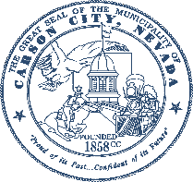 **Carson City**

# Mail Ballot Preference Form

**You have a choice.** Registered voters will receive mail ballots for all elections.

Use this form to let us know that:

* You want to vote in person and do not want a mail ballot. You must submit this form at least 60 days before the next election.

OR

* You now want to receive a mail ballot after you previously indicated you wanted to vote in person.

**Voter Information**

Last name First name

Middle name

Date of birth *(mm/dd/yyyy)*

## Permanent voter

## address

NV driver's license or ID card# *(if applicable)*

□□□□□□□□□□

**2** Street Unit# City State NV Zip

## Mail ballot preference

I **want to vote in person**

**Send me a ballot**

Check only one option.

Do not send me a ballot.

**OR**

**3** Submit this form at least 60 days before the next election so we can

remove your name from the

mailing lists.

I want to vote by mail in the following elections:

□All Future Elections

□Next Presidential Preference Election Only

□Next Primary Election Only

□Next General Election Only

□Next Special Election Only

## Where should we

**send your ballot?**

Check only one option.

Only complete this section

if you are voting by mail. **4**

**Contact information**

For official communication 5

only.

My permanent voter address in section 2

A different address:

**Street/ P.O. Box Unit#**

**City State Zip**

If you want this address to be your new permanent mailing address, go to registertovote.nv.gov to update your voter registration or check here:

Phone Email

(Your email address is confidential)

## Signature

**Required**

**For Official Use Only**

Registration #

I certify that all the information on this form is true and correct.

I understand that this will not affect my status as a registered voter.

**6 Voter signature Date *(mm/dd/yyyy)***

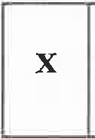

**You must submit this form at least 60 days before the next election.**